1 (a). Explain Memory Hierarchy with diagram
- The memory unit is an essential component in any digital computer since it is needed for storing programs and data. A very small computer with a limited application may be able to fulfill its intended task without the need of additional storage capacity.
- Most general-purpose computers would run more efficiently if they were equipped with additional storage beyond the capacity of the main memory.
- It is more economical to use low-cost storage devices to serve as a backup for storing the information that is not currently used by the CPU.
- The memory unit that communicates directly with the CPU is called the main memory. Devices that provide backup storage are called auxiliary memory. The most common auxiliary memory devices used in computer systems are magnetic disks and tapes. They are used for storing system programs, large data files, and other backup information. Only programs and data currently needed by the processor reside in main memory. All other information is stored in auxiliary memory and transferred to main memory when needed.
- The memory hierarchy system consists of all storage devices employed in a computer system from the slow but high-capacity auxiliary memory to a relatively faster main memory, to an even smaller and faster cache memory accessible to the high-speed processing logic.

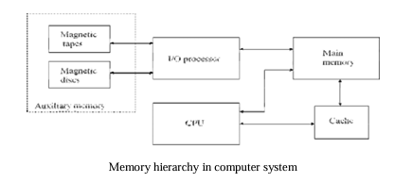
- The main memory occupies a central position by being able to communicate directly with the CPU and with auxiliary memory devices through an I/O processor.
- When programs not residing in main memory are needed by the CPU, they are brought in from auxiliary memory. Programs not currently needed in main memory are transferred into auxiliary memory to provide space for currently used programs and data.
- A special very-high speed memory called a cache is sometimes used to increase the speed of processing by making current programs and data available to the CPU at a rapid rate. The cache memory is employed in computer systems to compensate for the speed differential between main memory access time and processor logic.
- CPU logic is usually faster than main memory access time, with the result that processing speed is limited primarily by the speed of main memory.
- A technique used to compensate for the mismatch in operating speeds is to employ in extremely fast, small cache between the CPU and main memory whose access time is close to processor logic clock cycle time.
- The reason for having two or three levels of memory hierarchy is economics.
- As the storage capacity of the memory increases, the cost per bit for storing binary information decreases and the access time of the memory becomes longer.
- The overall goal of using a memory hierarchy is to obtain the highest-possible average access speed while minimizing the total cost of the entire memory system.
- Auxiliary and cache memories are used for different purposes. The cache holds those parts of the program and data that are most heavily used, while the auxiliary memory holds those parts that are not presently used by the CPU. Moreover, the CPU has direct access to both cache and main memory but not to auxiliary memory. The transfer from auxiliary to main memory is usually done by means of direct memory access of large blocks of data. The typical access time ratio between cache and main memory is about 1 to 7. For example, a typical cache memory may have an access time of 100ns, while main memory access time may be 700ns. Auxiliary memory average access time is usually 1000 times that of main memory. Block size in auxiliary memory typically ranges from256 to 2048 words, while cache block size is typically from 1 to 16 words.
- Many operating systems are designed to enable the CPU to process a number of independent programs concurrently. This concept, called multiprogramming, refers to the existence of two or more programs in different parts of the memory hierarchy at the same time.
- In a multiprogramming system, when one program is waiting for input or output transfer, there is another program ready to utilize the CPU.
- Computer programs are sometimes too long to be accommodated in the total space available in main memory.
- When the program or a segment of the program is to be executed, it is transferred to main memory to be executed by the CPU.
- It is the task of the operating system to maintain in main memory a portion of this information that is currently active.
- The part of the computer system that supervises the flow of information between auxiliary memory and main memory is called the memory management system.
(b) Differentiate between SRAM and DRAM
A)
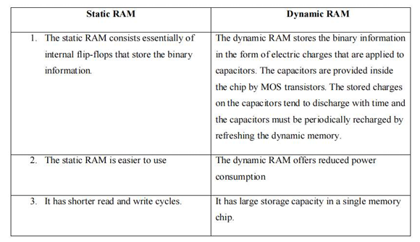

2) Explain ROM and its types.
A) A ROM chip is organized externally in a similar manner. ROM can only read, the data bus can only be in an output mode. The block diagram of a ROM chip is shown in Fig.
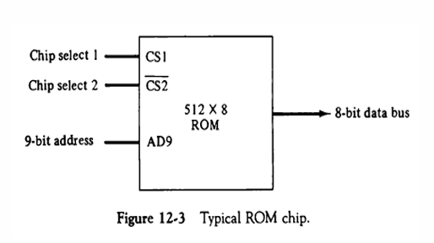
The nine address lines in the ROM chip specify any one of the 512 bytes stored in it. The two chip select inputs must be CS1 = 1 and CS2 = 0 for the unit to operate. Otherwise, the data bus is in a high-impedance state. There is no need for a read or write control because the unit can only read. Thus when the chip is enabled by the two select inputs, the byte selected by the address lines appears on the data bus.
3) Define Cache Memory. Explain in detail its mapping functions.
A) CACHE MEMORY
- Locality of Reference: The references to memory at any given time interval tends to be confined within a localized area. When a program loop is executed, the CPU repeatedly refers to the set of instructions in memory that constitute the loop.
- Every time a given subroutine is called, its set of instructions is fetched from memory. Thus loops and subroutines tend to localize the references to memory for fetching instructions.
- Iterative procedures refer to common memory locations and array of numbers are confined within a local portion of memory
- If the active portions of the program and data are placed in a fast small memory, the average memory access time can be reduced, thus reducing the total execution time of the program. Such a fast small memory is referred to as a cache memory. The cache is the fastest component in the memory hierarchy and approaches the speed of CPU components.
- When the CPU needs to access memory, the cache is examined. If the word is found in the cache, it is read from the fast memory. If the word addressed by the CPU is not found in the cache, the main memory is accessed to read the word. A block of words containing the one just accessed is then transferred from main memory to cache memory
- The performance of cache memory is frequently measured in terms of a quantity called hit ratio. When the CPU refers to memory and finds the word in cache, it is said to produce a hit. If the word is not found in cache, it is in main memory and it counts as a miss. The ratio of the number of hits divided by the total CPU references to memory (hits plus misses) is the hit ratio.
- The average memory access time of a computer system can be improved considerably by use of a cache. The transformation of data from main memory to cache memory is referred to as a mapping process. Three types of mapping procedures are:
2. Associative mapping
3. Direct mapping
4. Set-associative mapping.
- Consider the following memory organization:
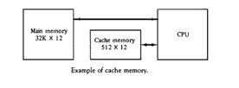
ASSOCIATIVE MAPPING
- The faster and most flexible cache organization use an associative memory. The associative memory stores both the address and content (data) of the memory word. This permits any location in cache to store any word from main memory.
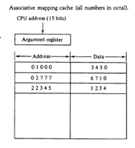
- A CPU address of 15 bits is placed in the argument register and the associative memory is searched for a matching address. If the address is found, the corresponding 12-bit data is read and sent to the CPU.
- If no match occurs, the main memory is accessed for the word. The address-data pair is then transferred to the associative cache memory. If the cache is full, an address−data pair must be displaced to make room for a pair that is needed and not presently in the cache.
- The decision as to what pair is replaced is determined from the replacement algorithm that the designer chooses for the cache. A simple procedure is to replace cells of the cache in round- robin order whenever a new word is requested from main memory. This constitutes a first-in first-out (FIFO) replacement policy.
DIRECT MAPPING
- Associative memories are expensive compared to random-access memories because of the added logic associated with each cell.
- Direct mapping uses RAM instead of CAM.
- The n-bit memory address is divided into two fields: k bits for the index field and n-k bits for the tag field. The direct mapping cache organization uses the n-bit address to access the main memory and the k-bit index to access the cache.
- The internal organization of the words in the cache memory is as shown in Fig Each word in cache consists of the data word and its associated tag. When a new word is first brought into the cache, the tag bits are stored alongside the data bits. When the CPU generates a memory request, the index field is used for the address to access the cache. 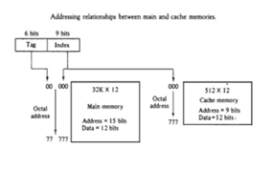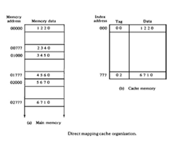
- The tag field of the CPU address is compared with the tag in the word read from the cache. If the two tags match, there is a hit and the desired data word is in cache. If there is no match, there is a miss and the required word is read from main memory. It is then stored in the cache together with the new tag, replacing the previous value.
- The disadvantage of direct mapping is that the hit ratio can drop considerably if two or more words whose addresses have the same index but different tags are accessed repeatedly.
- Suppose that the CPU now wants to access the word at address 02000. The index address is 000, so it is sued to access the cache. The two tags are then compared. The cache tag is 00 but the address tag is 02, which does not produce a match. Therefore, the main memory is accessed and the data word 5670 is transferred to the CPU. The cache word at index address 000 is then replaced with a tag of 02 and data of 5670.
- The direct-mapping uses a block size of one word. The same organization but using a block size of 8 words is shown in Fig. The index field is now divided into two parts: the block field and the word field. The tag field stored within the cache is common to all eight words of the same block.
- Every time a miss occurs, an entire block of eight words must be transferred from main memory to cache memory. Although this takes extra time, the hit ratio will most likely improve with a larger block size because of the sequential nature of computer programs.
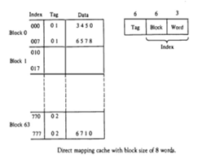
SET-ASSOCIATIVE MAPPING
- Set-associative mapping is an improvement over the direct-mapping organization in that each word of cache can store two or more words of memory under the same index address.
- Each data word is stored together with its tag and the number of tag-data items in one word of cache is said to form a set.
- Each index address refers to two data words and their associated tags. Each tag requires six bits and each data word has 12 bits, so the word length is 2(6 + 12) = 36 bits. An index address of nine bits can accommodate 512 words. Thus the size of cache memory is 512 × 36. It can accommodate 1024
- The words stored at addresses 01000 and 02000 of main memory are stored in cache memory at index address 000. Similarly, the words at addresses 02777 and 00777 are stored in cache at index address 777.
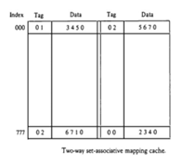
- When the CPU generates a memory request, the index value of the address is used to access the cache. The tag field of the CPU address is then compared with both tags in the cache to determine if a match occurs.
- The hit ratio will improve as the set size increases because more words with the same index but different tags can reside in cache.
- When a miss occurs in a set-associative cache and the set is full, it is necessary to replace one of the tag-data items with a new value. The most common replacement algorithms used are: random replacement, first-in first out (FIFO), and least recently used (LRU). WRITING INTO CACHE
- An important aspect of cache organization is concerned with memory write requests. If the operation is a write, there are two ways that the system can proceed.
- The simplest and most commonly used procedure is to up data main memory with every memory write operation, with cache memory being updated in parallel if it contains the word at the specified address. This is called the write-through method. This method has the advantage that main memory always contains the same data as the cache,. This characteristic is important in systems with direct memory access transfers.
- The second procedure is called the write-back method. In this method only the cache location is updated during a write operation. The location is then marked by a flag so that later when the words are removed from the cache it is copied into main memory. The reason for the write-back method is that during the time a word resides in the cache, it may be updated several times; however, as long as the word remains in the cache, it does not matter whether the copy in main memory is out of date, since requests from the word are filled from the cache. It is only when the word is displaced from the cache that an accurate copy need be rewritten into main memory.
CACHE INITIALIZATION
- The cache is initialized when power is applied to the computer or when the main memory is loaded with a complete set of programs from auxiliary memory. After initialization the cache is considered to be empty, built in effect it contains some non-valid data. It is customary to include with each word in cache a valid bit to indicate whether or not the word contains valid data.
- The cache is initialized by clearing all the valid bits to 0. The valid bit of a particular cache word is set to 1 the first time this word is loaded from main memory and stays set unless the cache has to be initialized again. The introduction of the valid bit means that a word in cache is initialization condition has the effect of forcing misses from the cache until it fills with valid data.
4a) Explain the importance of auxiliary memory.
- Auxilary Memory:
- The most common auxiliary memory devices used in computer systems are magnetic disks and magnetic tapes. Other components used, but not as frequently, are magnetic drums, magnetic bubble memory, and optical disks.
- The important characteristics of any device are its access mode, access time, transfer rate, capacity, and cost.
- The average time required to reach a storage location in memory and obtain its contents is called the access time. The access time consists of a seek time required to position the read- write head to a location and a transfer time required to transfer data to or from the device.
- Auxiliary storage is organized in records or blocks. A record is a specified number of characters or words. Reading or writing is always done on entire records. The transfer rate is the number of characters or words that the device can transfer per second, after it has been positioned at the beginning of the record.
- Magnetic drums and disks are quite similar in operation. Both consist of high-speed rotating surfaces coated with a magnetic recording medium. The rotating surface of the drum is a cylinder and that of the disk, a round flat plate. Bits are recorded as magnetic spots on the surface as it passes a stationary mechanism called a write head. Stored bits are detected by a change in magnetic field produced by a recorded spot on the surface as it passes through a read head.
Importance of Auxiliary Memory:
- Large Storage Capacity:
Auxiliary memory provides vast storage space compared to primary memory (RAM), making it ideal for storing operating systems, applications, documents, media files, and backups.
- Non-Volatile Storage:
It retains data even when the computer is turned off, unlike RAM. This ensures that data is not lost and can be accessed later.
- Cost-Effective:
Auxiliary memory is cheaper per unit of storage than primary memory, making it economical for storing large volumes of data.
- Data Backup and Archiving:
It is used to backup critical data and archive information for long-term storage and retrieval.
- Supports Multitasking and Performance:
Enables systems to run large programs and handle multiple processes by storing parts of data not immediately needed in primary memory.
- Essential for Booting:
The operating system is stored in auxiliary memory and loaded into RAM during the boot process.
4b) Explain hit and miss in the cache memory.
A)
- Locality of Reference: The references to memory at any given time interval tends to be confined within a localized area. ¬ When a program loop is executed, the CPU repeatedly refers to the set of instructions in memory that constitute the loop.
- Every time a given subroutine is called, its set of instructions is fetched from memory. Thus loops and subroutines tend to localize the references to memory for fetching instructions.
- Iterative procedures refer to common memory locations and array of numbers are confined within a local portion of memory
- If the active portions of the program and data are placed in a fast small memory, the average memory access time can be reduced, thus reducing the total execution time of the program. Such a fast small memory is referred to as a cache memory. The cache is the fastest component in the memory hierarchy and approaches the speed of CPU components.
- When the CPU needs to access memory, the cache is examined. If the word is found in the cache, it is read from the fast memory. If the word addressed by the CPU is not found in the cache, the main memory is accessed to read the word. A block of words containing the one just accessed is then transferred from main memory to cache memory
- The performance of cache memory is frequently measured in terms of a quantity called hit ratio. When the CPU refers to memory and finds the word in cache, it is said to produce a hit. If the word is not found in cache, it is in main memory and it counts as a miss. The ratio of the number of hits divided by the total CPU references to memory (hits plus misses) is the hit ratio.
- The average memory access time of a computer system can be improved considerably by use of a cache.
- The transformation of data from main memory to cache memory is referred to as a mapping process. Three types of mapping procedures are :
2. Associative mapping
3. Direct mapping
4. Set-associative mapping.
- Consider the following memory organization:


5) Differentiate Associative memory and cache memory.
A)CACHE MEMORY:
- Locality of Reference: The references to memory at any given time interval tends to be confined within a localized area. ¬ When a program loop is executed, the CPU repeatedly refers to the set of instructions in memory that constitute the loop.
- Every time a given subroutine is called, its set of instructions is fetched from memory. Thus loops and subroutines tend to localize the references to memory for fetching instructions.
- Iterative procedures refer to common memory locations and array of numbers are confined within a local portion of memory
- If the active portions of the program and data are placed in a fast small memory, the average memory access time can be reduced, thus reducing the total execution time of the program. Such a fast small memory is referred to as a cache memory. The cache is the fastest component in the memory hierarchy and approaches the speed of CPU components.
- When the CPU needs to access memory, the cache is examined. If the word is found in the cache, it is read from the fast memory. If the word addressed by the CPU is not found in the cache, the main memory is accessed to read the word. A block of words containing the one just accessed is then transferred from main memory to cache memory
- The performance of cache memory is frequently measured in terms of a quantity called hit ratio. When the CPU refers to memory and finds the word in cache, it is said to produce a hit. If the word is not found in cache, it is in main memory and it counts as a miss. The ratio of the number of hits divided by the total CPU references to memory (hits plus misses) is the hit ratio.
- The average memory access time of a computer system can be improved considerably by use of a cache.
- The transformation of data from main memory to cache memory is referred to as a mapping process. Three types of mapping procedures are :
2. Associative mapping
3. Direct mapping
4. Set-associative mapping.
- Consider the following memory organization:

ASSOCIATIVE MEMORY:
- Many data-processing applications require the search of items in a table stored in memory. An assembler program searches the symbol address table in order to extract the symbol’s binary equivalent.
- The number of accesses to memory depends on the location of the item and the efficiency of the search algorithm. Many search algorithms have been developed to minimize the number of accesses while searching for an item in a random or sequential access memory.
- The time required to find an item stored in memory can be reduced considerably if stored data can be identified for access by the content of the data itself rather than by an address.
- A memory unit accessed by content is called an associative memory or content addressable memory (CAM).
- When a word is to be read from an associative memory, the content of the word, or part of the word, is specified. The memory locates all words which match the specified content and marks them for reading.
- An associative memory is more expensive than a random access memory because each cell must have storage capability as well as logic circuits for matching its content with an external argument. For this reason, associative memories are used in applications where the search time is very critical and must be very short.
6 Explain the following.
a) Programmed I/O
b) Interrupt-initiated I/O
A) PROGRAMMED I/O
- In the programmed I/O method, the I/O device does not have direct access to memory. A transfer from an I/O device to memory requires the execution of several instructions by the CPU, including an input instruction to transfer the data from the device to the CPU, and a store instruction to transfer the data from the CPU to memory. Other instructions may be needed to verify that the data are available from the device and to count the numbers of words transferred.
- An example of data transfer from an I/O device through an interface into the CPU is shown in Fig
. 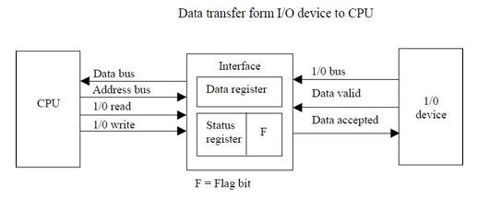
- The device transfers bytes of data one at a time as they are available. When a byte of data is available, the device places it in the I/O bus and enables its data valid line. The interface accepts the byte into its data register and enables the data accepted line. The interface sets a bit in the status register that we will refer to as an F or “flag” bit. The device can now disable the data valid line, but it will not transfer another byte until the data accepted line is disabled by the interface.
- A program is written for the computer to check the flag in the status register to determine if a byte has been placed in the data register by the I/O device. This is done by reading the status register into a CPU register and checking the value of the flag bit. If the flag is equal to 1, the CPU reads the data from the data register. The flag bit is then cleared to 0 by either the CPU or the interface, depending on how the interface circuits are designed. Once the flag is cleared, the interface disables the data accepted line and the device can then transfer the next data byte.
- A flowchart of the program that must be written for the CPU is shown in Fig. It is assumed that the device is sending a sequence of bytes that must be stored in memory. The transfer of each byte requires three instructions:
1. Read the status register.
2. Check the status of the flag bit and branch to step 1 if not set or to step 3 if set.
3. Read the data register.
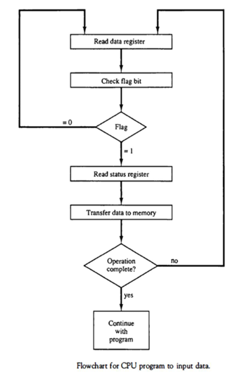
- Each byte is read into a CPU register and then transferred to memory with a store instruction. A common I/O programming task is to transfer a block of words form an I/O device and store them in a memory buffer.
- The programmed I/O method is particularly useful in small low-speed computers or in systems that are dedicated to monitor a device continuously. The difference in information transfer rate between the CPU and the I/O device makes this type of transfer inefficient.
INTERRUPT-INITIATED I/O
- An alternative to the CPU constantly monitoring the flag is to let the interface inform the computer when it is ready to transfer data. This mode of transfer uses the interrupt facility. While the CPU is running a program, it does not check the flag. However, when the flag is set, the computer is momentarily interrupted from proceeding with the current program and is informed of the fact that the flag has been set.
- The CPU deviates from what it is doing to take care of the input or output transfer. After the transfer is completed, the computer returns to the previous program to continue what it was doing before the interrupt.
- The CPU responds to the interrupt signal by storing the return address from the program counter into a memory stack and then control branches to a service routine that processes the required I/O transfer. The way that the processor chooses the branch address of the service routine varies from tone unit to another. In principle, there are two methods for accomplishing this. One is called vectored interrupt and the other, no vectored interrupt. In a non vectored interrupt, the branch address is assigned to a fixed location in memory. In a vectored interrupt, the source that interrupts supplies the branch information to the computer. This information is called the interrupt vector. In some computers the interrupt vector is the first address of the I/O service routine. In other computers the interrupt vector is an address that points to a location in memory where the beginning address of the I/O service routine is stored.
7a) Explain DMA with a sketch.
A)
7b) Explain about asynchronous data transfer.
A) ASYNCHRONOUS DATA TRANSFER
- The internal operations in a digital system are synchronized by means of clock pulses supplied by a common pulse generator.
- If the registers in the interface share a common clock with the CPU registers, the transfer between the two units is said to be synchronous.
- In most cases, the internal timing in each unit is independent from the other in that each uses its own private clock for internal registers. In that case, the two units are said to be asynchronous to each other.
- Asynchronous data transfer between two independent units requires that control signals be transmitted between the communicating units to indicate the time at which data is being transmitted.
- One way of achieving this is by means of a strobe pulse supplied by one of the units to indicate to the other unit when the transfer has to occur. Another method commonly used is to accompany each data item being transferred with a control signal that indicates the presence of data in the bus. The unit receiving the data item responds with another control signal to acknowledge receipt of the data. This type of agreement between two independent units is referred to as handshaking.
STROBE CONTROL
- The strobe control method of asynchronous data transfer employs a single control line to time each transfer. The strobe may be activated by either the source or the destination unit.
- The data bus carries the binary information from source unit to the destination unit. Typically, the bus has multiple lines to transfer an entire byte or word. The strobe is a single line that informs the destination unit when a valid data word is available in the bus.
- As shown in the timing diagram the source unit first places the data on the data bus. After a brief delay to ensure that the data settle to a steady value, the source activates the strobe pulse.
- The information on the data bus and the strobe signal remain in the active state for a sufficient time period to allow the destination unit to receive the data. Often, the destination unit uses the falling edge of the strobe pulse to transfer the contents of the data bus into one of its internal registers

HANDSHAKING
- The disadvantage of the strobe method is that the source unit that initiates the transfer has no way of knowing whether the destination unit has actually received the data item that was placed in the bus. Similarly, a destination unit that initiates the transfer has no way of knowing whether the source unit has actually placed the data on the bus. The handshake method solves this problem by introducing a second control signal that provides a reply to the unit that initiates the transfer.
- The basic principle of the handshaking method of data transfer is as follows. One control line is in the same direction as the data flow in the bus from the source to the destination. It is used by the source unit to inform the destination unit whether there are valued data in the bus.
8) Describe the modes of data transfer to and from peripherals with examples.
A)
- Binary information received from an external device is usually stored in memory for later processing. Information transferred from the central computer into an external device originates in the memory unit. The CPU merely executes the I/O instructions and may accept the data temporarily, but the ultimate source or destination is the memory unit.
- Data transfer between the central computer and I/O devices may be handled in a variety of modes. Some modes use the CPU as an intermediate path; other transfer the data directly to and from the memory unit.
- Data transfer to and from peripherals may be handled in one of three possible modes: 1. Programmed I/O 2. Interrupt-initiated I/O 3. Direct memory access (DMA)
- Programmed I/O operations are the result of I/O instructions written in the computer program. Each data item transfer is initiated by an instruction in the program. Usually, the transfer is to and from a CPU register and peripheral. Other instructions are needed to transfer the data to and from CPU and memory. Transferring data under program control requires constant monitoring of the peripheral by the CPU. Once a data transfer is initiated, the CPU is required to monitor the interface to see when a transfer can again be made. It is up to the programmed instructions executed in the CPU to keep close tabs on everything that is taking place in the interface unit and the I/O device.
- In the programmed I/O method, the CPU stays in a program loop until the I/O unit indicates that it is ready for data transfer. This is a time-consuming process since it keeps the processor busy needlessly. It can be avoided by using an interrupt facility and special commands to inform the interface to issue an interrupt request signal when the data are available from the device. In the meantime the CU can proceed to execute another program. The interface meanwhile keeps monitoring the device. When the interface determines that the device is ready for data transfer, it generates an interrupt request to the computer. Upon detecting the external interrupt signal, the CPU momentarily stops the task it is processing, branches to a service program to process the I/O transfer, and then returns to the task it was originally performing Transfer of data under programmed I/O is between CPU and peripheral.
- In direct memory access (DMA), the interface transfers data into and out of the memory unit through the memory bus. The CPU initiates the transfer by supplying the interface with the starting address and the number of words needed to be transferred and then proceeds to execute other tasks. When the transfer is made, the DMA requests memory cycles through the memory bus. When the request is granted by the memory controller, the DMA transfers the data directly into memory. The CPU merely delays its memory access operation to allow the direct memory I/O transfer. Since peripheral speed is usually slower than processor speed, I/O-memory transfers are infrequent compared to processor access to memory.
- Many computers combine the interface logic with the requirements for direct memory access into one unit and call it an I/O processor (IOP). The IOP can handle many peripherals through a DMPA and interrupt facility. In such a system, the computer is divided into three separate modules: the memory unit, the CPU, and the IOP.
PROGRAMMED I/O
- In the programmed I/O method, the I/O device does not have direct access to memory. A transfer from an I/O device to memory requires the execution of several instructions by the CPU, including an input instruction to transfer the data from the device to the CPU, and a store instruction to transfer the data from the CPU to memory. Other instructions may be needed to verify that the data are available from the device and to count the numbers of words transferred.
- An example of data transfer from an I/O device through an interface into the CPU is shown in Fig
. 
- The device transfers bytes of data one at a time as they are available. When a byte of data is available, the device places it in the I/O bus and enables its data valid line. The interface accepts the byte into its data register and enables the data accepted line. The interface sets a bit in the status register that we will refer to as an F or “flag” bit. The device can now disable the data valid line, but it will not transfer another byte until the data accepted line is disabled by the interface.
- A program is written for the computer to check the flag in the status register to determine if a byte has been placed in the data register by the I/O device. This is done by reading the status register into a CPU register and checking the value of the flag bit. If the flag is equal to 1, the CPU reads the data from the data register. The flag bit is then cleared to 0 by either the CPU or the interface, depending on how the interface circuits are designed. Once the flag is cleared, the interface disables the data accepted line and the device can then transfer the next data byte.
- A flowchart of the program that must be written for the CPU is shown in Fig. It is assumed that the device is sending a sequence of bytes that must be stored in memory. The transfer of each byte requires three instructions:
1. Read the status register.
2. Check the status of the flag bit and branch to step 1 if not set or to step 3 if set.
3. Read the data register.

- Each byte is read into a CPU register and then transferred to memory with a store instruction. A common I/O programming task is to transfer a block of words form an I/O device and store them in a memory buffer.
- The programmed I/O method is particularly useful in small low-speed computers or in systems that are dedicated to monitor a device continuously. The difference in information transfer rate between the CPU and the I/O device makes this type of transfer inefficient.
INTERRUPT-INITIATED I/O
- An alternative to the CPU constantly monitoring the flag is to let the interface inform the computer when it is ready to transfer data. This mode of transfer uses the interrupt facility. While the CPU is running a program, it does not check the flag. However, when the flag is set, the computer is momentarily interrupted from proceeding with the current program and is informed of the fact that the flag has been set.
- The CPU deviates from what it is doing to take care of the input or output transfer. After the transfer is completed, the computer returns to the previous program to continue what it was doing before the interrupt.
- The CPU responds to the interrupt signal by storing the return address from the program counter into a memory stack and then control branches to a service routine that processes the required I/O transfer. The way that the processor chooses the branch address of the service routine varies from tone unit to another. In principle, there are two methods for accomplishing this. One is called vectored interrupt and the other, no vectored interrupt. In a non vectored interrupt, the branch address is assigned to a fixed location in memory. In a vectored interrupt, the source that interrupts supplies the branch information to the computer. This information is called the interrupt vector. In some computers the interrupt vector is the first address of the I/O service routine. In other computers the interrupt vector is an address that points to a location in memory where the beginning address of the I/O service routine is stored.
9a) Differentiate between memory mapped I/O and isolated I/O.
- ISOLATED VERSUS MEMORY-MAPPED I/O
- Many computers use one common bus to transfer information between memory or I/O and the CPU. The distinction between a memory transfer and I/O transfer is made through separate read and write lines. The CPU specifies whether the address on the address lines is for a memory word or for an interface register by enabling one of two possible read or write lines. The I/O read and I/O write control lines are enabled during an I/O transfer. The memory read and memory write control lines are enabled during a memory transfer.
- In the isolated I/O configuration, the CPU has distinct input and output instructions, and each of these instructions is associated with the address of an interface register. When the CPU fetches and decodes the operation code of an input or output instruction, it places the address associated with the instruction into the common address lines. At the same time, it enables the I/O read (for input) or I/O write (for output) control line. This informs the external components that are attached to the common bus that the address in the address lines is for an interface register and not for a memory word. On the other hand, when the CPU is fetching an instruction or an operand from memory, it places the memory address on the address lines and enables the memory read or memory write control line. This informs the external components that the address is for a memory word and not for an I/O interface.
- The other alternative is to use the same address space for both memory and I/O. This is the case in computers that employ only one set of read and write signals and do not distinguish between memory and I/O addresses. This configuration is referred to as memory mapped I/O. The computer treats an interface register as being part of the memory system.
- In a memory-mapped I/O organization there is no specific input or output instructions. The CPU can manipulate I/O data residing in interface registers with the same instructions that are used to manipulate memory words. Each interface is organized as a set of registers that respond to read and write requests in the normal address space. Typically, a segment of the total address space is reserved for interface registers, but in general, they can be located at any address as long as there is not also a memory word that responds to the same address.
- Computers with memory-mapped I/O can use memory-type instructions to access I/O data. It allows the computer to use the same instructions for either input-output transfers or for memory transfers.
- The advantage is that the load and store instructions used for reading and writing from memory can be used to input and output data from I/O registers.
- In a typical computer, there are more memory-reference instructions than I/O instructions. With memory mapped I/O all instructions that refer to memory are also available for I/O. .
9b) Differentiate between I/O and Memory bus.
A)I/O VERSUS MEMORY BUS
- In addition to communicating with I/O, the processor must communicate with the memory unit. Like the I/O bus, the memory bus contains data, address, and read/write control lines. There are three ways that computer buses can be used to communicate with memory and I/O: 1. Use two separate buses, one for memory and the other for I/O. 2. Use one common bus for both memory and I/O but have separate control lines for each. 3. Use one common bus for memory and I/O with common control lines. In the first method, the computer has independent sets of data, address, and control buses, one for accessing memory and the other for I/O. This is done in computers that provide a separate I/O processor (IOP) in addition to the central processing unit (CPU). The memory communicates with both the CPU and the IOP through a memory bus. The IOP communicates also with the input and output devices through a separate I/O bus with its own address, data and control lines. The purpose of the IOP is to provide an independent pathway for the transfer of information between external devices and internal memory
10a) Explain I/O interface with block diagram.
- INPUT-OUTPUT INTERFACE
- Input-output interface provides a method for transferring information between internal storage and external I/O devices. Peripherals connected to a computer need special communication links for interfacing them with the central processing unit. The purpose of the communication link is to resolve the differences that exist between the central computer and each peripheral. The major differences are:
1. Peripherals are electromechanical and electromagnetic devices and their manner of operation is different from the operation of the CPU and memory, which are electronic devices. Therefore, a conversion of signal values may be required.
2. The data transfer rate of peripherals is usually slower than the transfer rate of the CPU, and consequently, a synchronization mechanism may be need.
3. Data codes and formats in peripherals differ from the word format in the CPU and memory.
4. The operating modes of peripherals are different from each other and each must be controlled so as not to disturb the operation of other peripherals connected to the CPU.
- To resolve these differences, computer systems include special hardware components between the CPU and peripherals to supervise and synchronize all input and output transfers. These components are called interface units because they interface between the processor bus and the peripheral device. In addition, each device may have its own controller that supervises the operations of the particular mechanism in the peripheral.
10b) Explain daisy chaining priority.
- DAISY-CHAINING PRIORITY
- The daisy-chaining method of establishing priority consists of a serial connection of all devices that request an interrupt. The device with the highest priority is placed in the first position, followed by lower-priority devices up to the device with the lowest priority, which is placed last in the chain.
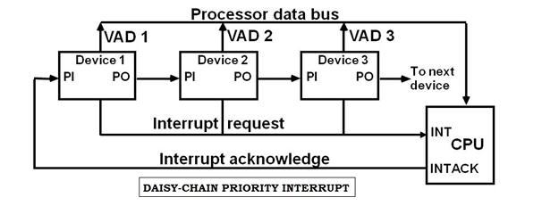
- The interrupt request line is common to all devices and forms a wired logic connection. If any device has its interrupt signal in the low-level state, the interrupt line goes to the low-level state and enables the interrupt input in the CPU. When no interrupts are pending, the interrupt line stays in the high-level state and no interrupts are recognized by the CPU.
- The CPU responds to an interrupt request by enabling the interrupt acknowledge line. This signal is received by device 1 at its PI (priority in) input. The acknowledge signal passes on to the next device through the PO (priority out) output only if device 1 is not requesting an interrupt.
- If device 1 has a pending interrupt, it blocks the acknowledge signal from the next device by placing a 0 in the PO output. It then proceeds to insert its own interrupt vector address (VAD) into the data bus for the CPU to use during the interrupt cycle.
- The device with PI = 1 and PO = 0 is the one with the highest priority that is requesting an interrupt, and this device places its VAD on the data bus.
- The following figure shows the internal logic that must be included with in each device when connected in the daisy-chaining scheme.
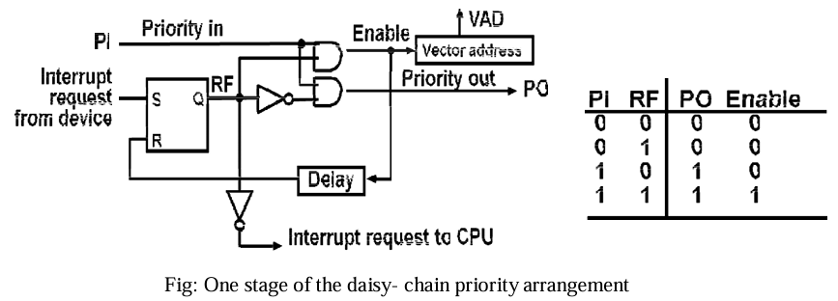
- The device sets its RF flip-flop when it wants to interrupt the CPU. The output of the RF flip- flop goes through an open-collector inverter, a circuit that provides the wired logic for the common interrupt line.
- If PI = 0, both PO and the enable line to VAD are equal to 0, irrespective of the value of RF.
- If PI = 1 and RF = 0, then PO = 1 and the vector address is disabled. This condition passes the acknowledge signal to the next device through PO.
- The device is active when PI = 1 and RF = 1. This condition places a 0 in PO and enables the vector address for the data bus. It is assumed that each device has its own distinct vector address.
- The RF flip-flop is reset after a sufficient delay to ensure that the CPU has received the vector address.

